Guardian share the following core characteristics
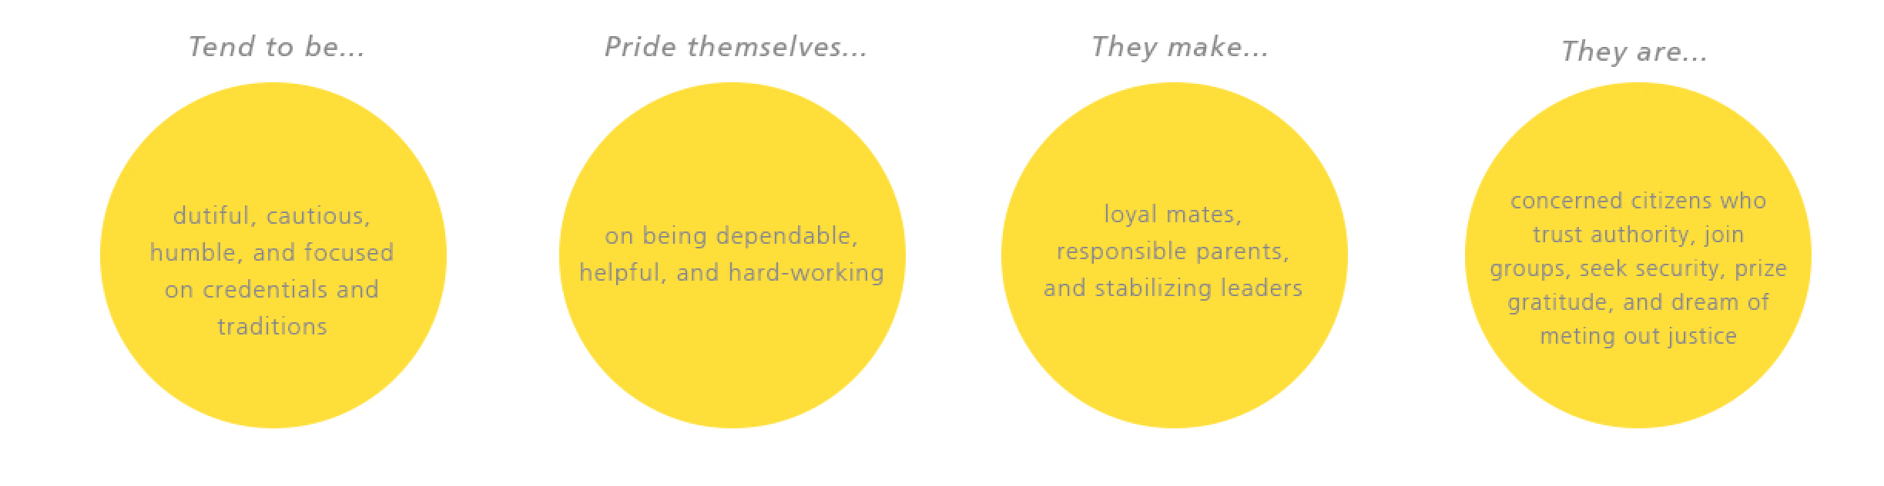
Guardians are the cornerstone of society, for they are the temperament given to serving and preserving our most important social institutions. Guardians have natural talent in managing goods and services--from supervision to maintenance and supply -- and they use all their skills to keep things running smoothly in their families, communities, schools, churches, hospitals, and businesses.
Guardians can have a lot of fun with their friends, but they are quite serious about their duties and responsibilities. Guardians take pride in being dependable and trustworthy; if there's a job to be done, they can be counted on to put their shoulder to the wheel. Guardians also believe in law and order, and sometimes worry that respect for authority, even a fundamental sense of right and wrong, is being lost. Perhaps this is why Guardians honor customs and traditions so strongly -- they are familiar patterns that help bring stability to our modern, fast-paced world.
Practical and down-to-earth, Guardians believe in following the rules and cooperating with others.
They are not very comfortable winging it or blazing new trails; working steadily within the system is the Guardian way, for in the long run loyalty, discipline, and teamwork get the job done right. Guardians are meticulous about schedules and have a sharp eye for proper procedures. They are cautious about change, even though they know that change can be healthy for an institution. Better to go slowly, they say, and look before you leap.
Guardians make up as much as 40 to 45 percent of the population, and a good thing, because they usually end up doing all the indispensable but thankless jobs the rest of us take for granted.
There are four types of Guardians
Although all Guardians share core characteristics, not all of them are the same. In Keirsey’s observations, he noted that there were four kinds of Guardians. They are: the Guardian Supervisor (ESTJ), Guardian Inspector (ISTJ), Guardian Provider (ESFJ), and Guardian Protector (ISFJ).
Supervisors are highly social and community-minded, with many rising to positions of responsibility in their school, church, industry, or civic groups. Supervisors are generous with their time and energy, and very often belong to a variety of service clubs, lodges, and associations, supporting them through steady attendance, but also taking an outspoken leadership role. Supervisors like to take charge of groups and are comfortable issuing orders.
Inspectors are extraordinarily persevering and dutiful, particularly when it comes to keeping an eye on the people and products they are responsible for. In their quiet way, Inspectors see to it that rules are followed, laws are respected, and standards are upheld. Inspectors (as much as ten percent of the general population) are the true guardians of institutions. They are patient with their work and with the procedures within an institution, although not always with the unauthorized behavior of some people in that institution.
Providers take it upon themselves to insure the health and welfare of those in their care, but they are also the most sociable of all the Guardians, and thus are the great nurturers of social institutions such as schools, churches, social clubs, and civic groups. Providers are very likely more than ten percent of the population, and this is fortunate for the rest of us, because friendly social service is a key to their nature. Wherever they go, Providers happily give their time and energy to make sure that the needs of others are met, and that social functions are a success.
Protectors make up as much as ten percent the population, because their primary interest is in the safety and security of those they care about - their family, their circle of friends, their students, their patients, their boss, their fellow-workers, or their employees. Protectors have an extraordinary sense of loyalty and responsibility in their makeup, and seem fulfilled in the degree they can shield others from the dirt and dangers of the world.

